KVIC Money Margin Claim Write up

- Each division will be allotted with the User ID and Auth ID.
- The concerned Nodal officer of the department will login to the Corporation Bank Portal exclusively developed for submitting the Margin Money claim.
- Link to be used to login to the portal is : https://www.corpbanknet.com/CapsUser/
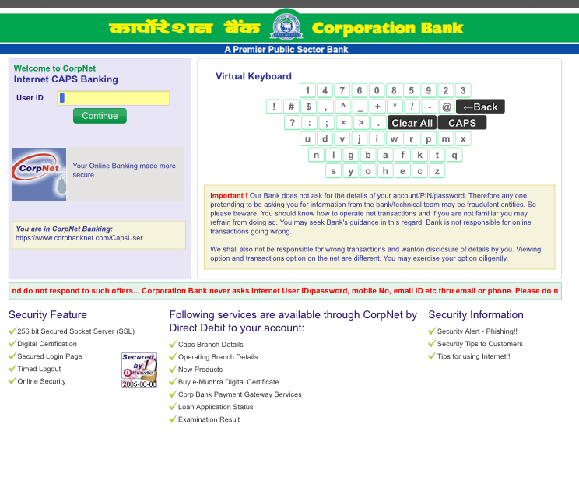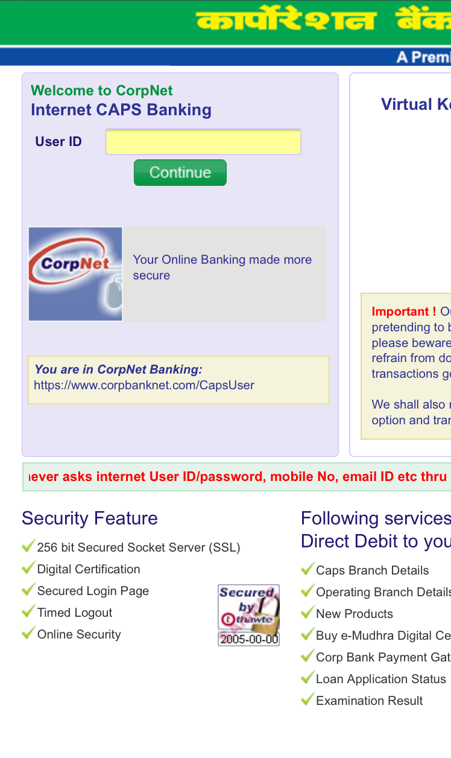
Enter User ID and click on continue
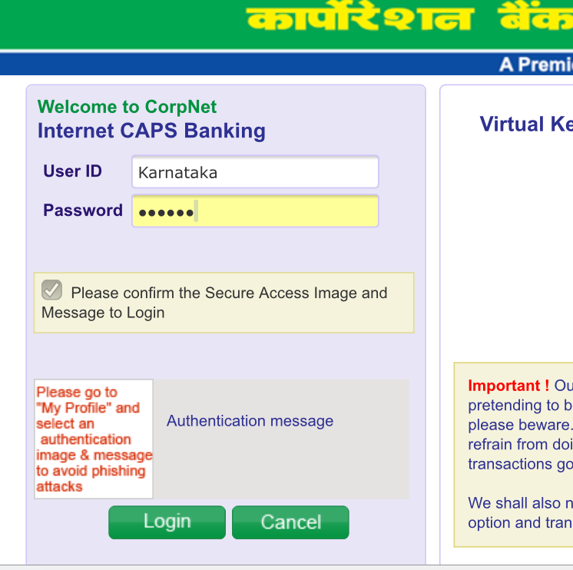
- After login to the portal. The nodal officer has to view the application number in the portal

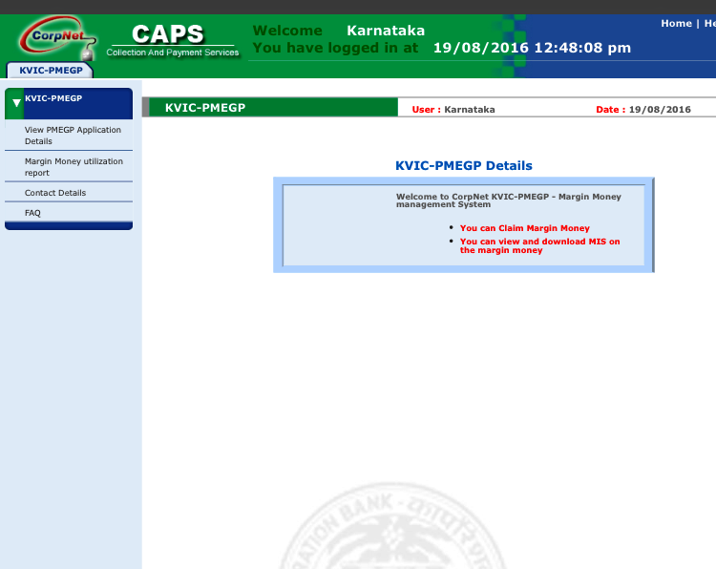
Click to view PMEGP Application

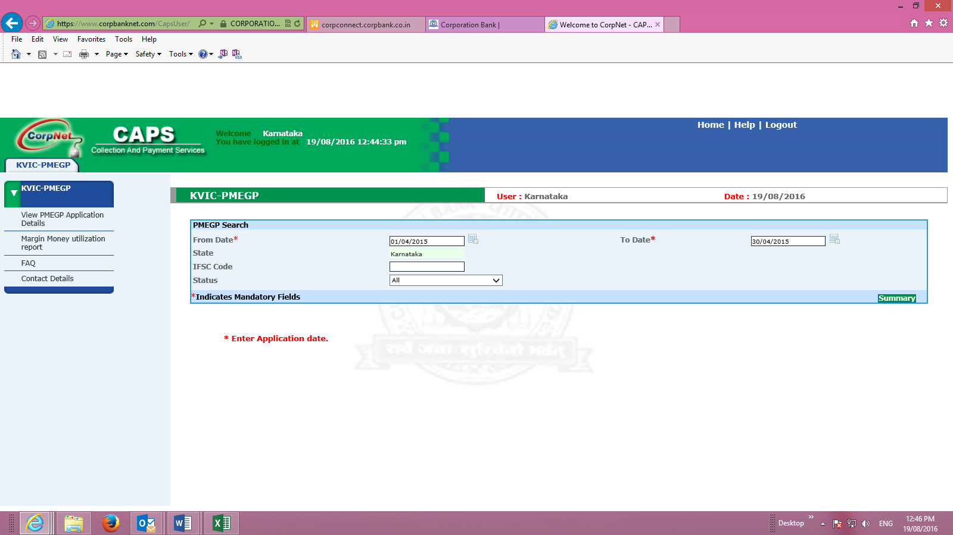
Give From and To Date: Please give Bank Finance Date here to get the application details

- The respective application number check box should be ticked and Claim margin money button has to be clicked
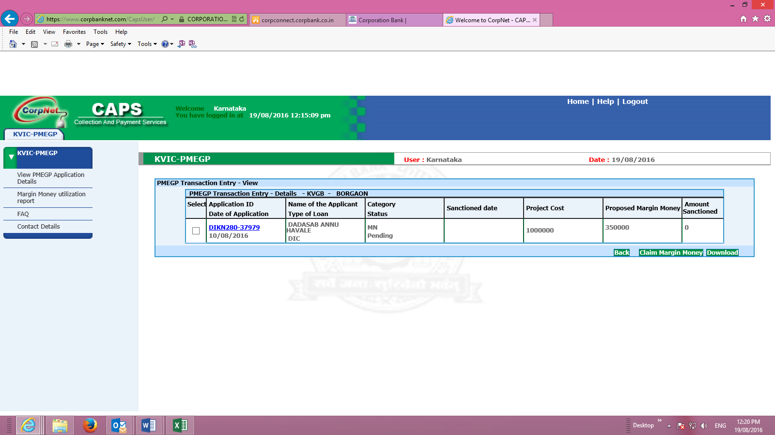

]
- The details have to be entered and updated.
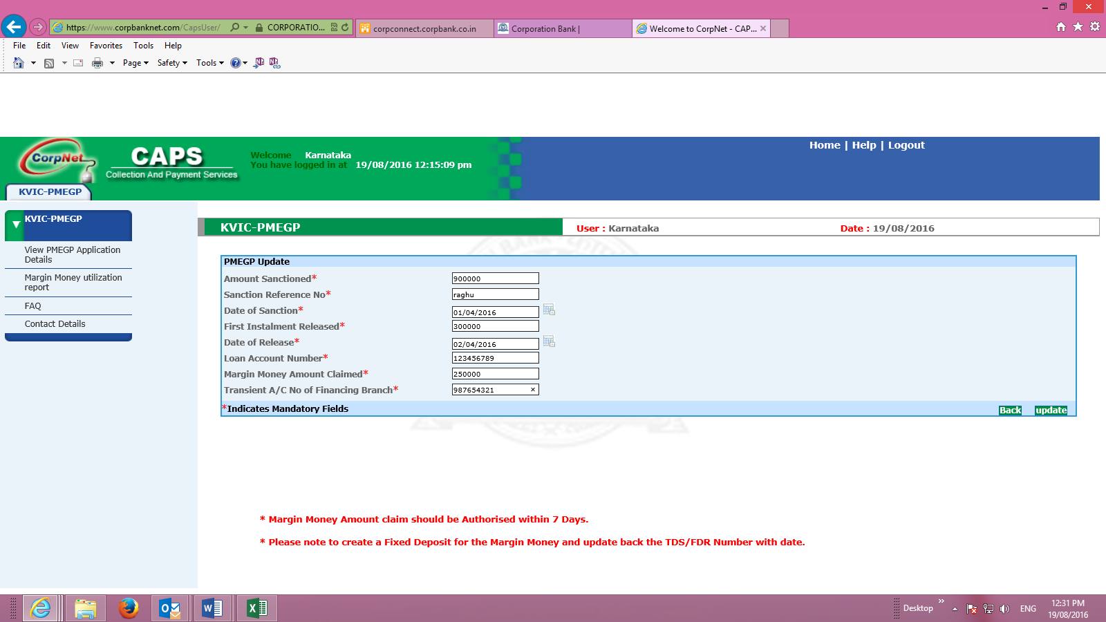

Once the claim is submitted, the authorizer should login and approve the same for disbursement. The authorization should be done within 7 business days.

